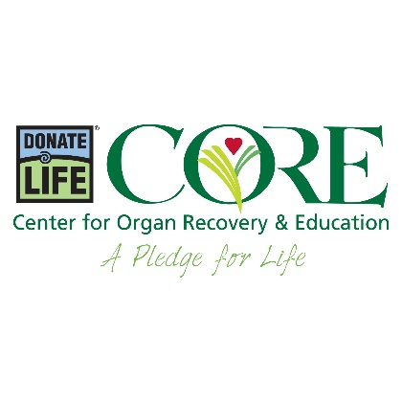

Obituary Templates

ORGAN, TISSUE AND CORNEA DONORS
- In keeping with [NAME]’s loving and generous spirit, it was [HIS/HER/THEIR] decision to donate life so that others may live.
- [HE/SHE/THEY] was known as a giving person and, even in death, [HIS/HER/THEIR] giving continues as [HIS/ HER/THEIR] donation of tissues will heal as many as 75 people.
- [NAME] gave the gift of life through organ, tissue and cornea donation.
- [HIS/HER/THEIR] corneas have restored sight for two people.
- Honoring [HIS/HER/THEIR] generous wish, the gift of life was shared with many people through organ, tissue and cornea donation.
- [NAME] gave in death as [HE/SHE/THEY] gave in life; [HE/SHE/THEY] was an organ donor.
- [NAME]’s final act of kindness was to give the gift of life through organ, tissue and cornea donation.
- [NAME] donated [HIS/HER/THEIR] heart valves to help other babies in need.
- The family requests that donations in [NAME]’s memory be directed to CORE, 204 Sigma Drive, Pittsburgh, PA 15238.

ORGAN, TISSUE OR CORNEA RECIPIENT
- [NAME] was an advocate for organ and tissue donation after receiving a transplant.
- [NAME] was a [ORGAN/TISSUE/CORNEA] recipient and a strong advocate for donation.
- Because of the gift of a [ORGAN/TISSUE/CORNEA] transplant, [NAME] was able to enjoy life with [HIS/HER/THEIR] family and friends.
- [NAME] shared many more years of life with [HIS/HER/THEIR] family and friends thanks to the generosity of an organ donor.
- The family requests that donations in [NAME]’s memory be directed to CORE, 204 Sigma Drive, Pittsburgh, PA 15238.

