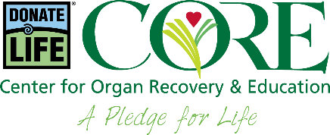

SAMPLE MESSAGE FROM THE CEO

[Organization Name] employees:

[Organization Name] has always been an organization that cares, and I know that you will care about this.

April is National Donate Life Month – a time to consider the life-saving possibilities of organ, tissue and donation and remember the donors who make donation and transplantation possible.

[Organization Name] is pleased to join the Hospital & Healthsystem Association of Pennsylvania (HAP) OR West Virginia Hospital Association (WVHA) and the Center for Organ Recovery & Education (CORE) to raise awareness about organ, tissue and cornea donation, and to inspire everyone to be a hero by registering as an organ donor during National Donate Life Month.

There are now more than 100,000 people in the United States who are waiting for a life-saving organ transplant. More than 7,000 of those waiting are listed here in Pennsylvania OR More than 500 of those waiting are West Virginians. A transplant can save their lives.

This National Donate Life Month, [Organization Name] asks everyone to consider how you can inspire others to provide hope through donor registration and living donation.

Approximately 11,000 people die annually who are considered medically suitable to donate organs, tissue and corneas, yet only a fraction donate. Anyone can be a potential donor regardless of age, race or medical history.

If you haven’t yet signed up as an organ donor, go registerme.org. Registration just takes a few minutes, and it could save lives.

I have committed to helping by registering. Won’t you join me?

[Name]
[Title]
[Organization]

